How to Register
- To register, please go to www.nhys.soccer and log in to your profile (upper right corner).
www.nhys.soccer
- Create a family profile (parent/guardian information used by all players in the family) if you do not have one. If you already created an account simply log in with your email and password or click on Forgot Password and a link to reset your password will be sent to your email.

- Add a family member (individual player)

- Once you complete the player information you will be directed to programming available for your child’s birth year. You may find some mandatory questions that do not pertain to you. Do not worry. Any information requested in the system you do not have you can put 0000000000 through (insurance policy number, etc.)

- Select program you wish to join (for this example we are using Middle School League)

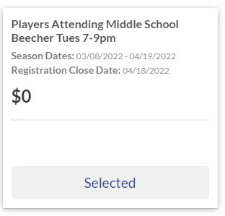

- Go to the blue Continue box on the bottom

- Answer specific questions about your child. Again, if you do not have answers you can put 000000000 through the required questions. View and accept the COVID 19 and Medical Release Waiver.
Go to the blue Continue box on the bottom
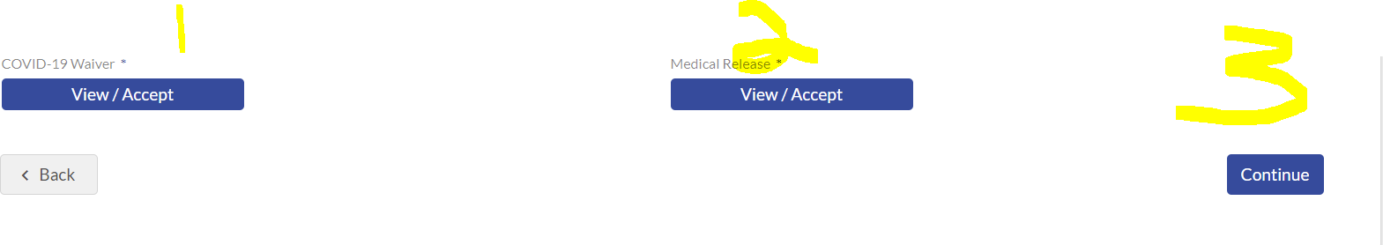

- Complete registration by “Checking Out”
If you have any questions, please contact Mike Galbicsek at admin@nhys.soccer today!

